Project Proposal Template
Agentic AI Applications Course

Team Number:
Team Member Name (s):
ADITYA KANTI(R23EA009)
AKASH O P(R23EA013)
Proposed Project Title: “Agentic AI Crowd Safety Monitoring System using Computer Vision”

Problem Statement & Use Case: Your problem statement should answer the following questions clearly:
Large public events such as concerts, festivals, railway stations, and stadiums often experience dangerous crowd congestion. When crowd density becomes too high, it can lead to accidents such as stampedes, panic situations, and injuries.
Currently, crowd monitoring is mostly done manually by security personnel watching CCTV footage. This approach is inefficient because humans may miss early warning signs of overcrowding or abnormal movement in large crowds.
The target users of this system are event organizers, security teams, and city authorities responsible for managing public safety in crowded places.
The proposed system uses AI-based computer vision and agentic decision-making to analyze live camera feeds and detect crowd density levels. The system can automatically identify overcrowded areas and classify risk levels such as safe, warning, or danger.
This problem is suitable for an agentic AI system because the AI agent can continuously monitor data, analyze patterns, make decisions, and trigger alerts without constant human supervision.

2. Justify that your application is Agentic?
This application requires agentic capabilities such as autonomous monitoring, tool usage, and decision-making.
Core Agentic Capabilities
Tool Use
The AI agent uses tools such as:
- Computer vision models (YOLO)
- OpenCV video processing
- Crowd density analysis
Planning & Decision Making
The agent analyzes crowd data and determines whether the situation is safe or dangerous.
Autonomous Monitoring
The agent continuously processes video frames and updates the crowd risk level.
Why Not a Simple LLM
If this were implemented as a simple LLM prompt or chatbot, it would not be able to:
- process real-time video streams
- detect people automatically
- analyze crowd density
- trigger safety alerts
Therefore, an agentic system with autonomous perception and decision-making is required.
Expected Agentic Behavior
Example:
The system receives a camera feed from a public event.
The agent detects the number of people present using a vision model.
If the crowd density exceeds a threshold, the agent automatically classifies the situation as High Risk and generates an alert message

3. High-Level Solution Overview
The proposed system consists of several AI components working together to monitor crowd safety.
Main Agents
1. Vision Agent
Detects people in images or video frames using object detection.
2. Crowd Analysis Agent
Counts the number of people and calculates crowd density.
3. Risk Prediction Agent
Determines whether the crowd level is safe, moderate, or dangerous.
4. Alert Agent
Sends warnings when crowd density exceeds safety limits.

Here is an example diagram:
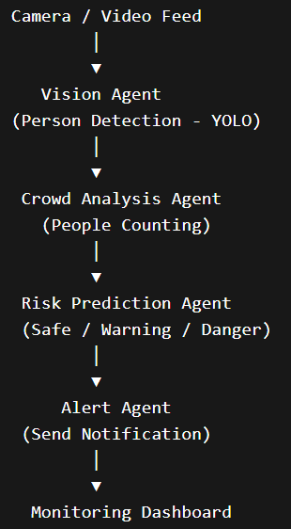

4. Proposed Technology Stack
LLM Provider
Optional lightweight LLM such as OpenAI GPT or Llama for generating alerts or explanations.
Core Framework
Python-based AI pipeline using:
- OpenCV
- Ultralytics YOLO
Tools Used
- Computer vision models
- Video processing tools
- Crowd counting algorithm
Vector Database
Not required for MVP, but Chroma DB may be used for storing past alerts.
Frontend / Delivery
Simple interface using:
- Streamlit dashboard
Evaluation Tools
Manual evaluation and performance metrics such as detection accuracy and processing time.
Deployment
Local deployment or cloud deployment using Hugging Face Spaces or Streamlit Cloud.

5. Success Metrics & Evaluation Plan (≈ ½ page)
To evaluate the effectiveness of the system, several metrics will be used.
Quantitative Metrics
Crowd Detection Accuracy
Percentage of correctly detected people in video frames.
Risk Classification Accuracy
Correct classification of safe vs dangerous crowd situations.
Processing Speed
Average time taken to process each frame.

Qualitative Evaluation
Human evaluators will observe the system output and assess:
- accuracy of crowd detection
- usefulness of alerts
- clarity of dashboard visualization
At least 20 test scenarios will be used, including:
- low crowd density
- moderate crowd density
- high crowd density

6. Risks, Challenges & Mitigation Plan

Risk 1: Incorrect crowd detection
Mitigation: Use pre-trained YOLO models and adjust detection thresholds.
Risk 2: Poor performance on crowded scenes
Mitigation: Use crowd datasets such as ShanghaiTech Crowd Dataset for testing.
Risk 3: High computational cost
Mitigation: Process video frames at lower resolution or lower frame rate.
Risk 4: False alerts
Mitigation: Use smoothing logic across multiple frames before triggering alerts

7. Timeline & Milestones
Week 1
- Finalize project topic
- Collect datasets
Week 2
- Implement person detection using YOLO
Week 3
- Implement crowd counting algorithm
Week 4
- Implement risk classification system
Week 5
- Build Streamlit dashboard
Week 6
- Testing and evaluation
Final Week
- Prepare project report and presentation

